

Waste Segregation System

**Team affiliation:**

22BCE8957 - SHRUTI GUGILWAR

22BEC7186 - SOURAV VIR SINGH

22BCE8204 - SHAMBHAVI GUNDA

22BCE9004 - AMAN YADAV

22BCE9167 - CHIRAG AGARWAL

22BCE9256 - SHRAWANI KULKARNI

Mentor: Dr Prof.Udit Narayana Kar

Project: Engineering Clinics-I

Date: 29th October 2023

University: Vellore Institute Of Technology, Amravati

**Abstract**This report presents the design and implementation of an automated waste segregation system using Arduino microcontroller technology. The system aims to address the growing challenge of waste management by effectively classifying and segregating waste into designated categories, promoting sustainable waste disposal practices.

The system employs a combination of sensors, including a moisture sensor, inductive proximity sensor, and infrared sensor, to accurately identify the type of waste. These sensors detect characteristics such as moisture content, metal presence, enabling precise waste classification.

To achieve efficient waste segregation, the system utilizes actuators, such as servo motors Servo motors precisely control the movement of waste items, directing them towards their respective receptacles.

A user interface, featuring an LCD display and LED indicators, provides real-time feedback on the waste identification process. The LCD display shows the type of waste being segregated, while the LED indicators illuminate corresponding lights as the waste item is directed to its designated receptacle. This visual reinforcement enhances user understanding and engagement with the system.

The implementation of this automated waste segregation system offers several benefits, including:

* Reduced manual labor and improved efficiency in waste segregation
* Accurate and consistent waste classification, minimizing contamination and maximizing recycling potential
* Enhanced user awareness and engagement in sustainable waste disposal practices
* Potential for integration into smart waste management systems

In conclusion, the automated waste segregation system developed in this project demonstrates the potential of Arduino technology to revolutionize waste management practices. The system's ability to effectively classify and segregate waste promotes sustainable waste disposal and contributes to environmental stewardship.

**Index  
  
List of Figures**

**Introduction**

A waste segregation system is a structured and organized approach to managing waste at various stages of its lifecycle. This system is designed to efficiently sort and categorize different types of waste, facilitating the responsible disposal, recycling, and treatment of materials. With the ever-growing global concern for environmental sustainability, waste segregation systems play a pivotal role in promoting a more circular and eco-friendly economy.

At its core, a waste segregation system involves the classification of waste into distinct categories based on its composition and characteristics. This categorization often includes separating biodegradable from non-biodegradable waste, identifying recyclable materials, and isolating hazardous substances. The objective is to optimize the recovery of valuable resources, reduce the environmental impact of waste disposal, and minimize the burden on landfills.

The benefits of a well-established waste segregation system are multifaceted. It not only contributes to environmental conservation by reducing the volume of waste sent to landfills but also promotes resource efficiency through the recycling of materials. Additionally, proper waste segregation helps prevent the contamination of soil and water sources, mitigates pollution, and supports the overall health of ecosystems.

In conclusion, a waste segregation system is an indispensable component of modern waste management strategies. By incorporating this system into daily practices, societies can move towards a more sustainable and responsible approach to handling waste, fostering a cleaner and healthier environment for current and future generations.   
 **Background**

Waste Management and segregation is a much-needed process in metro cities,rural areas and urban areas due to spreading of diseases. It is estimated that India produces 42.0 million tons of municipal solid waste annually at present.

Waste lying littered in the surrounding, dumped on open lands, becomes a major problem for various types of disease-causing bacteria and viruses hence, segregation, transport, handling and disposal of waste must be managed properly to minimize the risks of the public and environment. When mixed dry and wet waste breaks down in lowland, it creates nasty greenhouse gases.

One of the main demerits of the conventional waste management system is its inefficiency. The corresponding authority collects waste in the morning of each day and goes to every garbage bin to collect waste. It is a major limitation of the traditional system as the amount of waste for every place is not the same.Segregation makes it attainable to utilize and recycle the waste effectively.

This waste segregator system can easily segregate waste.

**Problem Definition**

The current waste management practices suffer from a significant lack of effective waste segregation at the source, leading to numerous environmental, health, and logistical challenges. The improper disposal of mixed waste hampers recycling efforts, increases the burden on landfills, and poses hazards to public health and the ecosystem. The key issues associated with the existing waste segregation system include:

**1.Mixed Waste Disposal:**

* Many households and businesses do not engage in proper waste segregation at the source, resulting in the disposal of mixed waste.
* The lack of awareness, education, or convenient segregation methods contributes to the prevalent practice of discarding recyclable, organic, and hazardous waste together.

**2.Environmental Impact:**

* Mixed waste disposal contributes to environmental pollution, as certain materials take longer to decompose and release harmful substances into the soil, water, and air.
* The environmental consequences of improper waste segregation are detrimental to ecosystems, biodiversity, and overall environmental sustainability.

**3.Health Risks:**

* Improperly segregated waste poses health risks to waste management workers and the general public due to exposure to hazardous materials and contaminants.
* The lack of segregation increases the likelihood of accidents and injuries during waste handling and disposal processes.

**4.Logistical Challenges:**

* Municipal waste management systems face increased operational challenges and costs when dealing with mixed waste.
* The inefficiencies in collection, transportation, and processing of mixed waste result in higher resource utilization and increased strain on existing waste management infrastructure.

**5.Wasted Resources:**

* The absence of effective waste segregation leads to missed opportunities for resource recovery and recycling.
* Valuable materials that could be reused or recycled are lost in landfills, contributing to the depletion of natural resources and increasing the need for raw materials.

Addressing these challenges requires the implementation of a comprehensive waste segregation system that emphasizes education, awareness, infrastructure development, and policy support. A well-designed and effectively executed waste segregation system can significantly contribute to sustainable waste management, environmental conservation, and the promotion of a circular economy.

**Objectives of the proposed work**

The objective of this project is to design and implement an automated waste segregation system using Arduino. The system will use a variety of sensors to identify the type of waste, and it will use actuators to segregate the waste into different categories. The system will also be able to display the type of waste to the user.

**Methodology/Procedure**

**1.PROPOSED SYSTEM**

The system will work as follows:

1. The waste will be placed in container as the input of the system.
2. The sensors will read the waste and determine its type.
3. The Arduino board will control the servo motors to move the appropriate waste bin.
4. The container with the waste will drop down the waste to the waste bin.
5. The Arduino board will display the type of waste on the LCD display.

The following is a more detailed description of the methodology for each type of waste:

Metallic waste:

1. The sensor will detect the metallic waste.
2. The Arduino board will control the servo motor to move to the metallic waste bin.
3. The container with the waste will drop down the waste to the metallic waste bin.
4. The Arduino board will display "Metallic waste" on the LCD display.

Dry waste:

1. The sensor will detect the dry waste.
2. The Arduino board will control the servo motor to move to the dry waste bin.
3. The container with the waste will drop down the waste to the dry waste bin.
4. The Arduino board will display "Dry waste" on the LCD display.

Wet waste:

1. The moisture sensor will detect the wet waste.
2. The Arduino board will control the servo motor to move to the wet waste bin.
3. The container with the waste will drop down the waste to the wet waste bin.
4. The Arduino board will display "Wet waste" on the LCD display.

**1.2 COMPONENTS**

MECHANICAL

1. Supporting Frame

A frame is often a structural system that supports other components of a physical construction and/or steel frame that limits the construction's extent. Here the Frame allows us to mount all other components on it

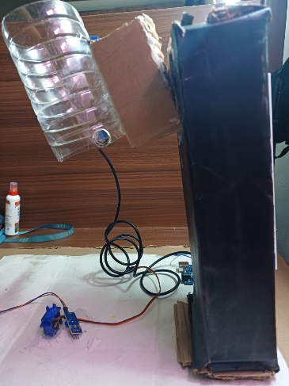

2. Collecting Bins and moving disk

The collecting bins are used to collect the segregated waste in the respective bins

Moving Disc is the component whose primary task is to collect trash in the respective bin with the help of the servo motor. All the trash collecting bins will be placed on it

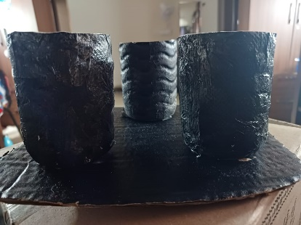

ELECTRICAL

1. IR Sensor

IR sensor is one of the most commonly used sensors in the field of electronics; it has a large number of applications at the domestic as well as at the industrial level. IR module is a sensor module that consists of both IR transmitter and a receiver.

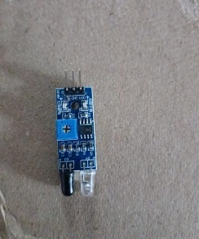

2. Metal Sensor

An Inductive Proximity Sensor is a non-contact electronic proximity sensor used for the detection of metals. Sensing range of this sensor completely depends upon the metal being detected. Their working principle is based on a coil and an oscillator that generates an electromagnetic field in the surrounding of the sensing range. Presence of any metallic substance in the sensing range causes dampening of oscillation amplitude.

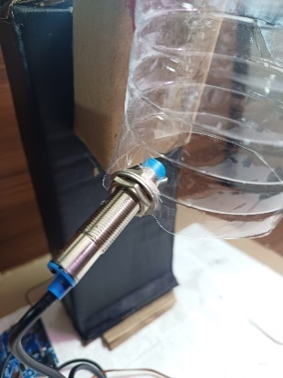

3. LCD

This is a flat panel display that uses properties of liquid crystals. LCD displays do not emit light directly, instead, they use a backlight to develop images in single color. LCD displays are used in a wide range of applications like television panel, computer monitors and instrument panels as well. Here the LCD Displays the status the result of the trash detected

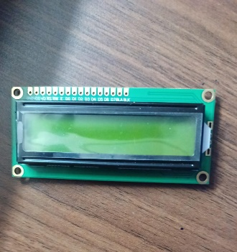

4. Servo Motor

A servomotor is a rotary actuator or linear actuator that allows for precise control of angular or linear position, velocity and acceleration.[1] It consists of a suitable motor coupled to a sensor for position feedback. It also requires a relatively sophisticated controller, often a dedicated module designed specifically for use with servomotors.

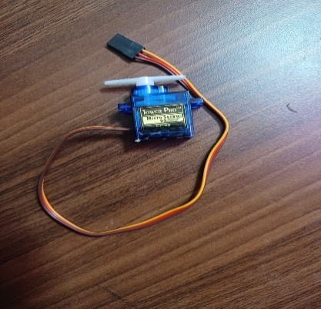

5. Bread board

Breadboards are designed to work with any electronic component that has metal leads or pins that can be plugged into the holes on a breadboard

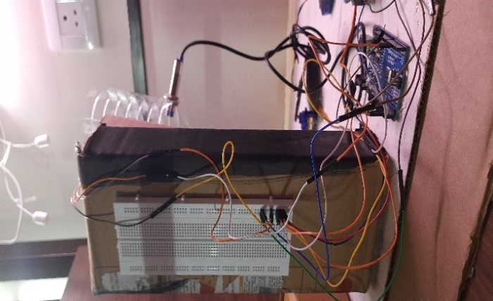

6.MoistureSensor

As the name indicates, this sensor is used to measure the moisture content in a given material. These sensors use the volumetric water content indirectly by making use of some other properties like electrical resistance, dielectric constant. In general cases, the sensor generates a voltage proportional to the dielectric permittivity and therefore measures the moisture content of a material.

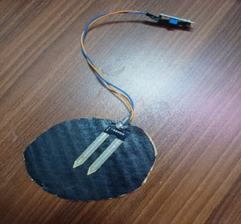

**2.2 WORKING**

1. Drop the waste into the pipe.

2. IR sensor will sense the waste and it will rest on the bottom plate

3. Now the sensor on the plate will sense the waste as in 3 categories Metallic or wet.

4. Now the algorithm is so made that if the waste is metallic then the mechanism will bring the metal collecting bin below the pipe and the servo will let the waste fall into the bin.

5. Similarly, the process will be repeated for wet test.

6. If the sensor does not activate then the waste will be detected as dry waste.

**Results and Discussion**

Waste management and dumping of solid waste in India have been researched and the findings show that municipal solid wastes are mostly composed of biodegradables and non-biodegradable materials. The consequences of poor waste management are manifested in environmental degradation, road encroachment, air pollution, residential land encroachment, and loss of aesthetic view of the metropolis. The findings and solutions presented in this paper will serve as useful guides for improved waste management services within the metropolis and regions with similar waste challenges in India and other developing countries.  
The complete structure of the bin and its working procedure is already mentioned in this paper. Different components mentioned in the paper such as Arduino,servo motor,moisture sensor,inductive metal sensor to develop the prototype is shown in (figure). Finally, the prototype was checked for different conditions to observe whether it works perfectly or not.

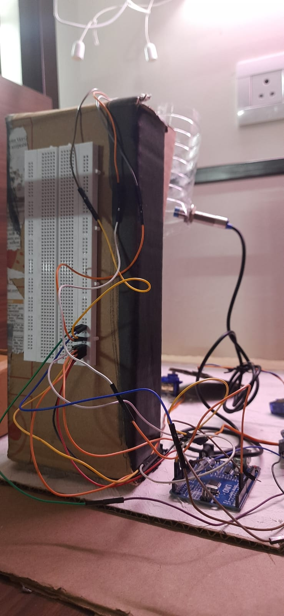

**Conclusion and Future Scope**

In conclusion, the development and implementation of automatic waste segregation models represent a significant stride towards enhancing the efficiency and sustainability of waste management systems. These innovative technologies have the potential to revolutionize the way we handle and process waste by leveraging advanced algorithms and sensor-based systems to automate the sorting process. As we reflect on the current state of waste management and the challenges posed by escalating amounts of waste, automatic waste segregation models emerge as a promising solution.

The adoption of such models not only streamlines the sorting process but also addresses issues related to human error and variability in manual waste segregation. Automation brings precision and consistency, ensuring that materials are sorted accurately based on their composition, leading to increased rates of recycling and a reduction in the volume of waste destined for landfills.

Looking ahead, the future scope for automatic waste segregation models is both exciting and expansive. Continued research and development in artificial intelligence, machine learning, and sensor technologies are likely to enhance the capabilities and accuracy of these models. Integration with smart waste management systems could enable real-time monitoring, allowing for more dynamic and adaptive waste sorting processes.

Furthermore, the scalability of automatic waste segregation models opens up possibilities for their implementation in various settings, from residential areas to industrial facilities. Governments, municipalities, and private entities may increasingly invest in these technologies to optimize waste management practices and achieve ambitious sustainability goals.

However, challenges such as cost, technological accessibility, and public acceptance must be addressed to ensure the widespread adoption of automatic waste segregation models. Continued collaboration between the scientific community, policymakers, and industry stakeholders will be essential to navigate these challenges and promote the development of practical and economically viable solutions.

In essence, the future of automatic waste segregation models holds great promise in revolutionizing how we manage and process waste. By harnessing the power of technology, we have the potential to create more efficient, environmentally friendly, and sustainable waste management systems that contribute significantly to a healthier planet.

**References**

1. <https://nevonprojects.com/automatic-waste-segregation-system/>

2.<https://www.sciencedirect.com/science/article/pii/S2542660520300901>

3.<https://www.who.int/news-room/fact-sheets/detail/health-care-waste>

4.<https://www.iswa.org/wmr/?v=c86ee0d9d7ed>  
5.<https://www.arduino.cc/reference/en/>

6.<https://docs.arduino.cc/built-in-examples/>

7.<https://www.semanticscholar.org/paper/IoT-Based-Automated-Waste-Segregator-for-Efficient-Saminathan-Musipatla/c05ed54e512f6b8dcd1baa56227ca5cf7a40356f>

8.<https://www.semanticscholar.org/paper/MICROCONTROLLER-BASED-WASTE-SEGREGATOR-AND-OF-WET-Nandini-Chaitra/2eca8c6c1bc668c6f495973c1c09be94af4d53cf>

9.<https://www.semanticscholar.org/paper/Implementation-of-an-Automatic-Waste-Segregator-Uno-Sunehra-Pravalika/ffaf2a946e0dda64b044d27d1e2f9e289fc62848>

10.<https://www.semanticscholar.org/paper/IoT-based-Automatic-Waste-segregator-Lopes-Machado/41f044c59bf3b291775c5bfb0a63a47ab0e6e006>

11.<https://www.semanticscholar.org/paper/AUTOMATED-WASTE-SEGREGATOR-Gimonkar/4fb45fa1b2072953d621277ec52932f81eeac3cc/figure/6>

12.<https://www.researchgate.net/publication/349530230_Smart_Waste_Segregation_and_Monitoring_System_using_IoT>

13. <https://arduinopoint.com/ir-sensor-arduino-project/>

14. <https://projecthub.arduino.cc/nikolaiapalis/simple-soil-moisture-sensor-ec23c7>

15. <https://electropeak.com/learn/interfacing-inductive-proximity-sensor-lj12a3-4-z-3-wire-with-arduino/>

**Codes in Appendix**



**Servo Motor: Moisture Sensor:**

 

**Inductive Metal Sensor:**



#include <Servo.h>

class Smart_Segregator

{

  public:

    int servo_pin;

    int moisture_sensor_pin;

    int touch_sensor_pin;

    int detect_moisture;

    int detect_touch;

    Servo servo;

    Smart_Segregator(int pin_1, int pin_2, int pin_3)

    {

      servo_pin = pin_1;

      moisture_sensor_pin = pin_2;

      touch_sensor_pin = pin_3;

      detect_moisture = 0;

      detect_touch = false;

    }

    void init()

    {

      Serial.begin(9600);

      servo.attach(servo_pin);

      servo.write(90);

      pinMode(moisture_sensor_pin, INPUT);

      pinMode(touch_sensor_pin, INPUT);

      Serial.println("Your Smart Segregator is ready to Segregate!");

    }

    void dry_waste()

    {

      servo.write(0);

    }

    void wet_waste()

    {

      servo.write(180);

    }

    void neutral_state()

    {

      servo.write(90);

    }

    void execute()

    {

      detect_moisture = analogRead(moisture_sensor_pin);

      detect_touch = digitalRead(touch_sensor_pin);

      if (detect_moisture > 85 && detect_touch == true)

      {

        wet_waste();

      }

      else if (detect_moisture <= 85 && detect_touch == true)

      {

        dry_waste();

      }

      else

      {

        neutral_state();

      }

    }

}

Servo myservo;

Servo conveyar;

void moistureDetection(curr, max){

  if(curr/max   <= 0.1){

    myservo.write(0)

   }else

   {

    myservo.write(180)

  }

}

int IRSensor = A0;

int moisture_sensor=  A1;

int metal_sensor = 11;

int pos = 0;

int max= 0;

void setup()

{

  conveyar.attach(10);

  pinMode(metal_sensor, INPUT);

  myservo.attach(9);

  Serial.begin(9600);

  Serial.println("Serial Working");

  pinMode(IRSensor, INPUT);

  pinMode (moisture_sensor, INPUT);

 max = analogRead(moisture_sensor);

}

void loop()

{

  int curr = analogRead(moisture_sensor);

 int sensorStatus = digitalRead(IRSensor);

  if (sensorStatus == 1)

  {

    myservo.write(0);

    digitalWrite(LED, LOW);

    Serial.println("werty");

  }

  else  {

    myservo.write(180);

    digitalWrite(LED, HIGH);

    Serial.println("asdfgh");

  }

Serial.println(digitalRead(metal_sensor)||digitalRead(IRSensor));

  if(curr/max   <= 0.5){ //If the moisture is below 10%

    myservo.write(0);

   }else if(curr/max>0.5)  //Otherwise the moisture level is above 60%, and therefore it's good enough

   {

    myservo.write(180);

    int i = 0;

    while (i<180){

      conveyar.write(i);

      delay(10);

        i++;

    }

  / }

  if(digitalRead(metal_sensor)||digitalRead(IRSensor)){

    conveyar.write(0);

    myservo.write(0);

  }else{

    conveyar.write(180);

    myservo.write(90);

  }

}